A kind reminder to Highland Creek Residents: Please remember that blocking sidewalks with parked vehicles (especially when parking your cars in your driveway), yard waste, recycling carts and anything that impedes their use results in an enforceable ordinance violation.

While sidewalks obstructions may seem like a minor nuisance, they pose a major danger for residents (pedestrians, runners, mothers with children, and the disabled) whom are forced to step into the road, or cross the street to use the sidewalk on the other side.

In spring and summer, more and more Highland Creek Residents (and their children) will be using the sidewalks to walk to pools, parks, and facilities. Please be considerate.

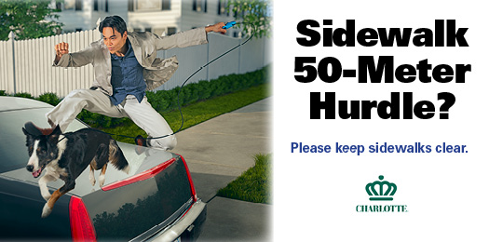

In spring and summer, more and more Highland Creek Residents (and their children) will be using the sidewalks to walk to pools, parks, and facilities.

Very often, when parking cars in the driveway, we inadvertently obstruct the sidewalk, and we impede pedestrians from using it.

Please be considerate. Be careful not to cause inconvenience or put others in danger.

Remember to keep our sidewalks clear and if you see obstructions, please call the Law Enforcement Non Emergency phone line: 311 (Mecklenburg) or (704) 920.5000 (Cabarrus).

